INTERVIEW QUESTION

**INTERVIEWER: Tshenolo Nthubu**

**INTERVIEWEE: Themba Moeng**

**Date: 18/09/25**

**Time: 11:55**

Q1: Can you tell me in simple terms what the main purpose of this banking system should be?  
-To allow customers to securely manage their money by creating accounts, making deposits, withdrawals, and viewing their transaction history.

Q2: What kinds of customers do you expect the system to support? For example, individuals, companies, or both?  
-Primarily individual customers, but with the potential to support small businesses in the future.

Q3: What types of accounts should customers be able to open in the system?  
-Basic savings accounts, checking (cheque) accounts, and potentially fixed-deposit investment accounts.

Q4: How do you imagine a customer will register or sign up in the system?  
-Through a online form where they provide their personal details, contact information, and proof of ID.

Q5: Should the system include a login feature with usernames and passwords, or some other form of authentication?  
-Yes, a standard username and password login is essential for customer access.

Q6: When a customer makes a deposit, how should that process work in the system?  
-They should be able to select an account and enter an amount to deposit, which immediately updates the account balance.

Q7: For withdrawals, are there any rules or restrictions we need to keep in mind depending on the account type?  
-Yes, savings accounts might have a limit on monthly withdrawals, while checking accounts would allow for more frequent transactions.

Q8: How should interest be handled for savings and investment accounts? Should it be calculated automatically each month?  
-Yes, interest should be calculated and added to the account balance automatically at the end of each month.

Q9: Do you want the system to keep a history of transactions for each customer?  
-Absolutely. A permanent history of all deposits and withdrawals for each account is a must-have.

Q10: Should there be any limits on how many accounts a single customer can have?  
-No, a single customer should be able to open multiple accounts of different types.

Q11: For cheque accounts, what kind of employment details should the customer provide?  
-Their current employer's name and their monthly income should be sufficient.

Q12: In terms of usability, what do you expect the system's interface to look and feel like? Simple, professional, modern?  
-A clean, professional, and modern interface that is easy for customers to navigate.

Q13: How important is security for this system, and what measures would you expect to see (e.g., password strength, encryption)?  
-Extremely important. Passwords must be encrypted, and all data transmissions should be secure (SSL/TLS).

Q14: Do you want the system to be accessible only in the bank (internal use), or also by customers themselves (like online banking)?

-Both. Bank staff need an internal interface, and customers need secure online access.

Q15: Finally, if you could describe the "must-have" features --- the ones that absolutely cannot be left out --- what would they be?

-User registration/login, creating savings/checking accounts, depositing/withdrawing money, viewing transaction history, and strong security.

UML DIAGRAMS

DATA FLOW DIAGRAM

This represents the relationship between the customer and their account when they are paying.

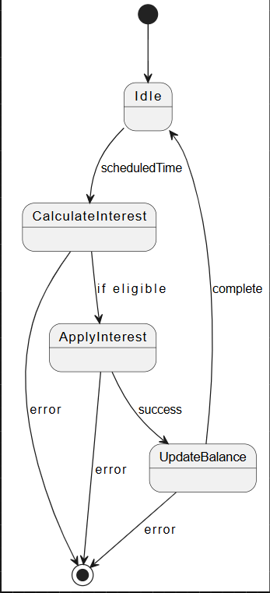

DEPOSIT

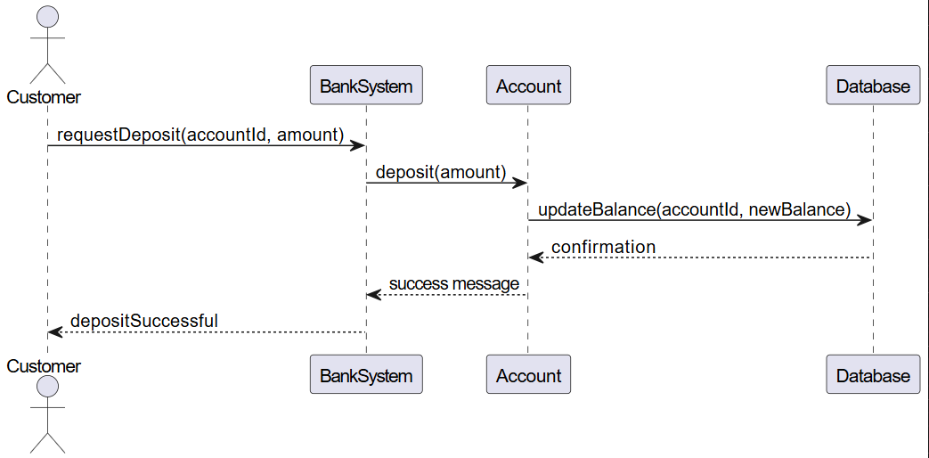

ENTITY RELATIONSHIP DIAGRAM

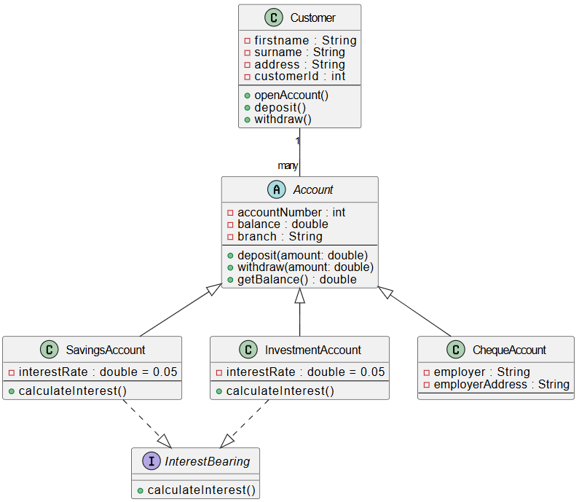

LOGIN

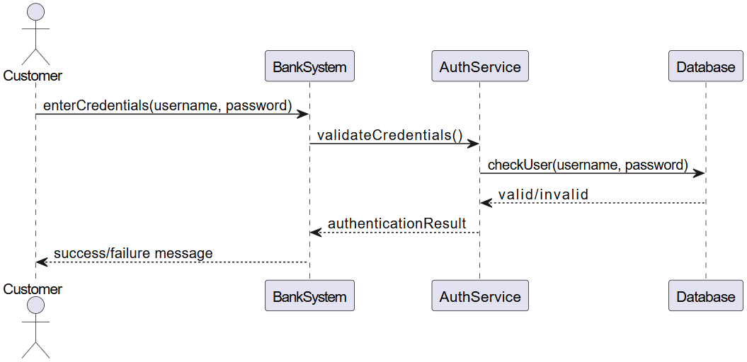

CASE DIAGRAM

